IU2541230103 – CPP66 – PROJECT REPORT
Sports Equipment Management
Enrollment No.: IU2541230103
Student Name: DAVE JUHI
Semester: 3
Subject: C++ Guided Project
GitHub Repository: https://github.com/<your-username>/Sports-Equipment-Management

1. Introduction
Sports clubs, schools and colleges own a lot of shared equipment such as cricket bats, footballs, badminton rackets and nets. Members borrow this equipment for practice and matches, yet in many places the issue and return of items is still written in a paper register. This makes it hard to know which items are available, who is holding which item, and whether returned items were damaged or lost.
The Sports Equipment Management system is a console-based application written in C++ that keeps all this information in one place. It is built using Object-Oriented Programming: equipment, members, allocations and returns are modelled as classes derived from a common abstract base class (Record). A system class (SportsCenter) coordinates the work, a template container (Store<T>) manages dynamic memory, and a FileManager class stores all data in text files so that records survive after the program is closed.

2. Problem Statement
Sports clubs, schools and colleges lend bats, balls, rackets and other gear to members, but most still track issues and returns in registers. Items go missing, nobody knows who holds what, damaged gear is put back into circulation and records are easily lost. This project provides a console-based C++ application that records equipment and members, issues and returns items with validation, tracks the condition of every returned item and stores all data permanently in files.
The problem is therefore to design and implement a menu-driven C++ program that stores equipment, member, allocation and return records, validates every input, prevents invalid issues and returns, produces a report, and saves all data permanently to files.

3. Objectives
- Apply OOP concepts (encapsulation, inheritance, runtime polymorphism) to a real problem.
- Manage equipment, member, allocation and return records with add, display, search, update and delete.
- Implement the main transactions: issue equipment to a member and return it, with validation.
- Use dynamic memory and file handling for persistent storage.
- Validate input and handle errors with exceptions.
- Generate a report that summarises stock, issued items and members.

4. Functional Requirements
- FR1 – Add Record: add equipment (name, type) or a member (name, 10-digit phone).
- FR2 – Display Records: list all equipment, members, allocations or returns.
- FR3 – Search Record: search equipment, members or allocations by ID or keyword (name, type, status, phone, date).
- FR4 – Update Record: modify the name, type or status of equipment, or the name and phone of a member.
- FR5 – Delete Record: delete equipment or a member; deletion is refused while an item is issued, and the related history is removed with the record.
- FR6 – Main Transaction: issue equipment to a member and return it; reject unknown IDs, unavailable items, a fourth item for a member, invalid dates and returns dated before the issue.
- FR7 – Report: show totals, stock by status, currently issued items and members holding nothing.
- FR8 – Save / Load: save to and load from data files; data is loaded automatically at start and saved at exit.
- FR9 – Validation and error handling: reject invalid names, phone numbers, dates and menu choices without crashing.

5. System / Project Flow
The overall flow of the program is:
USER → Main Menu (main.cpp / SportsCenter::run) → SportsCenter system class → Entity classes in Store<T> (Equipment, Member, Allocation, Return) → FileManager → FILE (Data/*.txt)
main.cpp only creates the SportsCenter object and calls run(). At start-up, run() calls FileManager::load() to restore old records. The user then chooses menu options; each option is handled by a SportsCenter member function that validates input, works on the Store<T> containers and prints the result. When the user chooses Exit, FileManager::save() writes all records back to the data files. The program therefore follows the required cycle: START → Load existing records → Perform operations → Save updated records → EXIT.

6. Class Descriptions
Class | Data Members | Member Functions | Responsibility
Record (abstract) | id, name | Record(), Record(id,name), ~Record(), getId(), getName(), setName(), display()=0, serialize()=0, deserialize()=0, typeName()=0 | Abstract base class giving every entity a common id/name and a polymorphic interface.
Equipment | type, status (+ id, name) | Equipment(), Equipment(id,name,type,status), ~Equipment(), updateStatus(), isAvailable(), display(), serialize(), deserialize() | Stores one sports item and its current status.
Member | phone (+ id, name) | Member(), Member(id,name,phone), ~Member(), getPhone(), setPhone(), display(), serialize(), deserialize() | Stores a member who can borrow equipment.
Allocation | equipmentId, memberId, date, returned (+ id) | Allocation(), Allocation(id,eId,mId,date), ~Allocation(), allocate(), isReturned(), setReturned(), display(), serialize(), deserialize() | Records one issue of an item to a member (result of the issue transaction).
Return | allocationId, date, condition (+ id) | Return(), Return(id,aId,date,cond), ~Return(), processReturn(), display(), serialize(), deserialize() | Records the return of an issued item and its condition (result of the return transaction).
Store<T> (template) | items (T*), count, capacity | Store(cap), ~Store(), add(), at(), indexOfId(), removeAt(), nextId(), clear(), grow() | Dynamic array built with new[] / delete[]; grows automatically.
SportsCenter (system class) | Store<Equipment>, Store<Member>, Store<Allocation>, Store<Return>, FileManager, dirty | SportsCenter(), ~SportsCenter(), addEquipment(), addMember(), issueEquipment(), returnEquipment(), deleteEquipment(), deleteMember(), report(), saveAll(), loadAll(), run() | Controls the whole system: owns all data, implements every menu option and both transactions.
FileManager | dir (data folder) | FileManager(), FileManager(dir), ~FileManager(), save(SportsCenter&), load(SportsCenter&) | Writes and reads the four data files; reports corrupt data with exceptions.
AppException, ValidationException, InputClosedException | (inherit std::runtime_error) | constructors | Exception hierarchy for validation, logic and file errors.

7. OOP Concepts Used
- Classes & Objects: Equipment, Member, Allocation, Return, SportsCenter and FileManager are classes; main() creates a SportsCenter object.
- Encapsulation: Data members are private or protected and are accessed only through getters and setters, e.g. Member::getPhone() / setPhone().
- Constructors (default + parameterized): Every entity has Class() and Class(id, ...), e.g. Equipment() and Equipment(id, name, type, status); Store(cap) and FileManager(dir) are parameterized.
- Destructors: Virtual ~Record() and derived destructors; ~Store() calls delete[] items to release memory; ~SportsCenter() lets its Stores clean up automatically.
- Inheritance: Equipment, Member, Allocation and Return inherit from Record; ValidationException and InputClosedException inherit from AppException, which inherits from std::runtime_error.
- Runtime Polymorphism: Record declares pure virtual display(), serialize(), deserialize() and typeName(). The showAll() helper and FileManager::saveStore() call them through Record* pointers, so the correct derived version runs at run time.
- Dynamic Memory: Store<T> allocates T* items = new T[capacity], doubles it with grow() when full and frees it with delete[]. Dynamic memory is needed because the number of records is not known in advance.
- File Handling: FileManager uses ifstream / ofstream to save and load equipment.txt, members.txt, allocations.txt and returns.txt.
- Validation: validateName(), validatePhone(), validateDate(), validateText() and readInt() re-prompt until correct input is entered.
- Exception Handling: try / catch blocks handle AppException, ValidationException and InputClosedException in the input helpers, SportsCenter::run() and file operations; invalid IDs, unavailable items and corrupt files are reported cleanly.

8. File Handling and Data Persistence
Data is stored in plain text files inside the Data/ folder, one record per line with fields separated by the ‘|’ character:
- equipment.txt – id|name|type|status
- members.txt – id|name|phone
- allocations.txt – id|equipmentId|memberId|date|returned
- returns.txt – id|allocationId|date|condition
On start-up, FileManager::load() reads every file line by line, splits it and calls the entity’s deserialize() method. A missing file is treated as an empty list (first run). A corrupt line raises an AppException with the file name and line number, and in that case the program does not overwrite the damaged files when it exits. On exit (or through menu option 8), FileManager::save() rewrites all files. The ‘|’ character is rejected during input so the file format can never be broken. Test T15 closes and reopens the program and confirms that old records are still available.

9. UML Diagrams
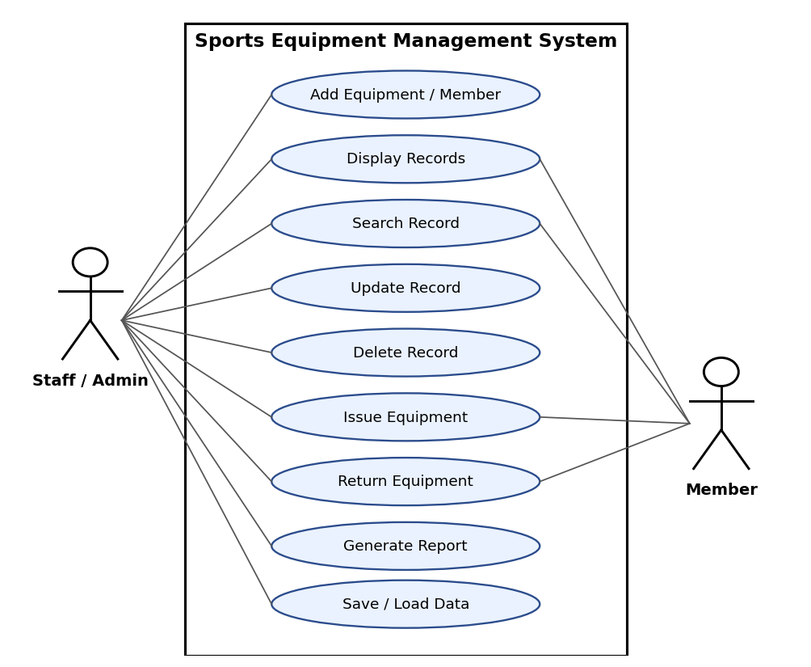
Figure 1: Use Case Diagram (2 actors, 9 use cases)
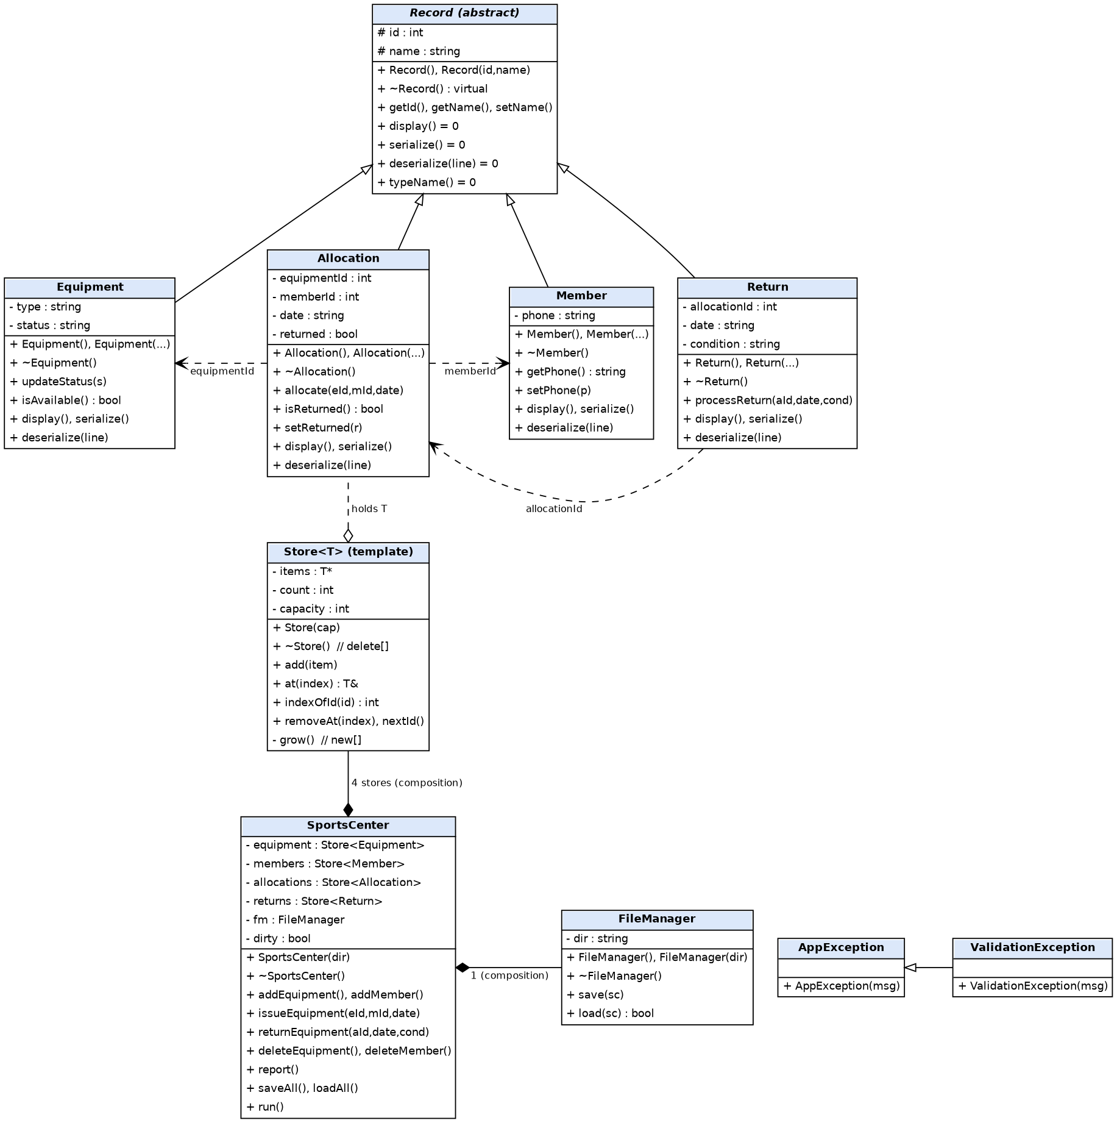
Figure 2: Class Diagram
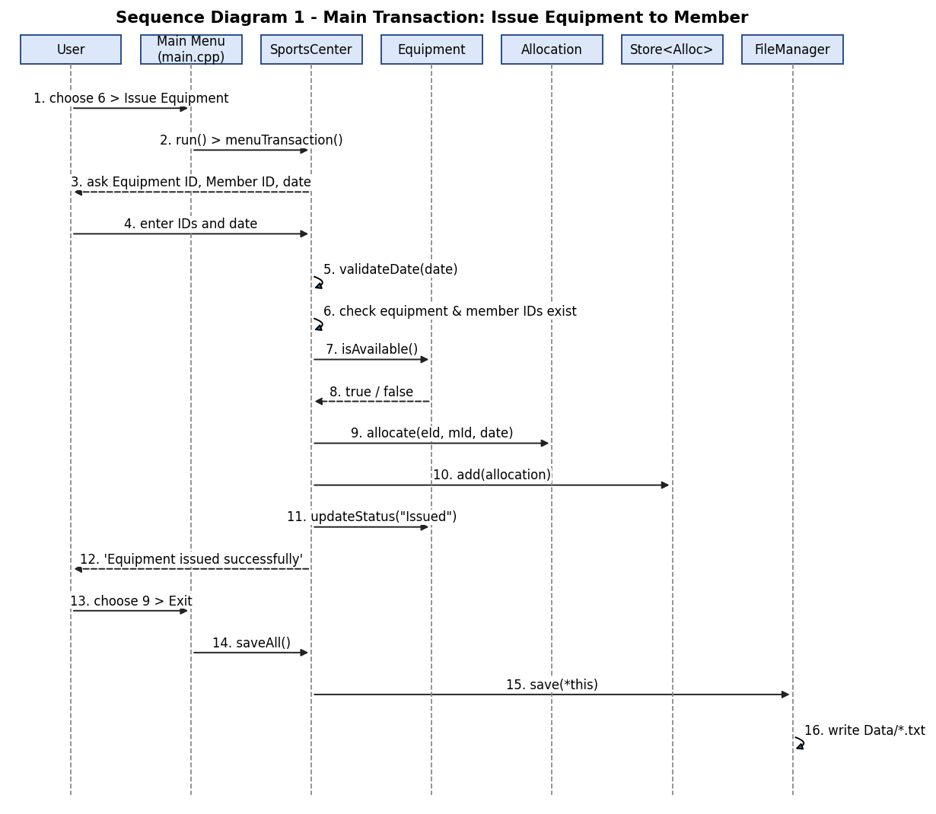
Figure 3: Sequence Diagram 1 – Main Transaction (Issue Equipment to Member)
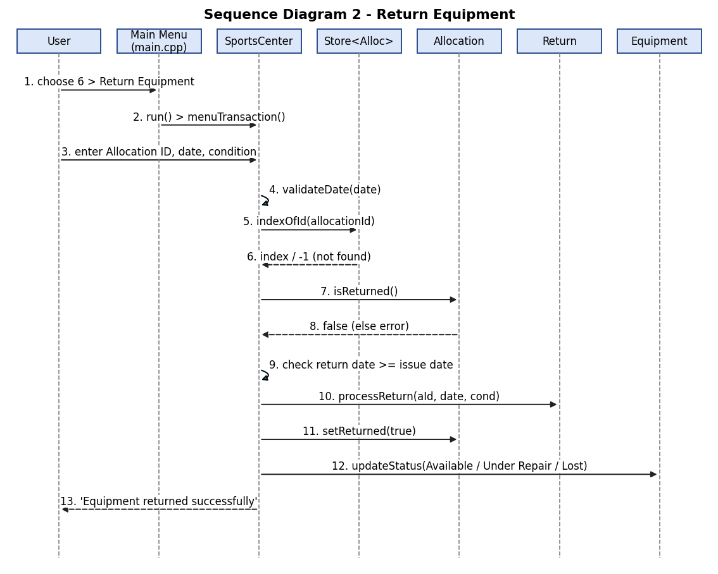
Figure 4: Sequence Diagram 2 – Return Equipment

10. Implementation Details
The program is written in C++11 and compiled with g++. The source is divided into one header/source pair per class, which keeps main.cpp very small:
- main.cpp – creates the SportsCenter object and calls run().
- Record.h/.cpp – abstract base class.
- Equipment, Member, Allocation, Return (.h/.cpp) – entity classes.
- Store.h – template dynamic array.
- SportsCenter.h/.cpp – system class with all menu logic and the main transactions.
- FileManager.h/.cpp – file save/load.
- Utils.h/.cpp – validation, input helpers and exception classes.
Main transaction – issueEquipment(): the function (1) validates the date, (2) checks that the equipment ID and member ID exist, (3) rejects equipment whose status is not Available, (4) rejects a member who already holds 3 items, and (5) creates an Allocation object, calls allocate(), adds it to Store<Allocation> and sets the equipment status to Issued. Failures throw AppException, which the menu loop catches and displays.
Main transaction – returnEquipment(): the function checks that the allocation exists and is not already returned, rejects a return date earlier than the issue date, creates a Return object with processReturn(), marks the allocation as returned, and sets the equipment status to Available (Good), Under Repair (Damaged) or Lost.
Memory safety: the program was also compiled with AddressSanitizer and UndefinedBehaviorSanitizer and all 15 tests were re-run; no memory leaks or errors were reported.
Compilation: g++ -std=c++11 main.cpp SportsCenter.cpp FileManager.cpp Record.cpp Equipment.cpp Member.cpp Allocation.cpp Return.cpp Utils.cpp -o SportsEquipment (or simply run make).

11. Testing and Results
Test ID | Input / Operation | Expected | Actual | Status
T01 | Add Equipment  Name: Cricket Bat, Type: Cricket | Equipment added with ID 1. | Equipment added with ID 1. | Pass
T02 | Add Equipment (duplicate)  Cricket Bat, then 'cricket bat' again | First: Equipment added with ID 1.  Second: Equipment with this name already exists. | Equipment added with ID 1.  Equipment with this name already exists. | Pass
T03 | Add Member  Name: Riya Shah, Phone: 9876543210 | Member added with ID 1. | Member added with ID 1. | Pass
T04 | Add Member (validation)  Phone '12345' then valid 9876543211 | Phone must be exactly 10 digits.  Then: Member added with ID 1. | Phone must be exactly 10 digits.  Member added with ID 1. | Pass
T05 | Display Equipment  Menu 2 > 1 after adding Football | Equipment (1)  Football listed. | --- Equipment (1) ---  ID: 1 | Football | Football | Available | Pass
T06 | Search Equipment  Keyword 'bat' | 1 record(s) found.  Cricket Bat listed. | 1 record(s) found.  ID: 1 | Cricket Bat | Cricket | Available | Pass
T07 | Search (no match)  Keyword 'xyz' | No matching record found. | No matching record found. | Pass
T08 | Update Equipment  ID 1 -> name 'Cricket Bat Pro', type unchanged, status unchanged | Record updated.  Name changed to Cricket Bat Pro. | Record updated.  ID: 1 | Cricket Bat Pro | Cricket | Available | Pass
T09 | Main Transaction: Issue Equipment  Equipment 1, Member 1, date 10/10/2026 | Equipment issued successfully. Allocation ID: 1. | Equipment issued successfully. Allocation ID: 1. | Pass
T10 | Issue (item already issued)  Same equipment issued again to member 2 | Second issue rejected: Equipment is not available (status: Issued). | Equipment issued successfully. Allocation ID: 1.  Equipment is not available (status: Issued). | Pass
T11 | Issue (date validation)  Date 31/02/2026 then 11/10/2026 | Invalid date (day out of range for month).  Then: issued, Allocation ID: 1. | Invalid date (day out of range for month).  Equipment issued successfully. Allocation ID: 1. | Pass
T12 | Main Transaction: Return Equipment  Allocation 1, date 15/10/2026, condition Good | Returned successfully, Return ID 1, Condition Good.  Status back to Available. | Equipment returned successfully. Return ID: 1. Condition: Good.  ID: 1 | Cricket Bat | Cricket | Available | Pass
T13 | Return (damaged item)  Allocation 1, date 15/10/2026, condition Damaged | Returned successfully, Condition Damaged.  Status becomes Under Repair. | Equipment returned successfully. Return ID: 1. Condition: Damaged.  ID: 1 | Cricket Bat | Cricket | Under Repair | Pass
T14 | Delete Equipment (blocked, then cascade)  Delete issued item; return it; delete again; Report | Delete blocked while issued.  After return: Record deleted.  Total equipment: 0, Total allocations: 0. | Cannot delete: this equipment is currently issued to a member.  Record deleted.  Total equipment: 0  Total allocations: 0 | Pass
T15 | File persistence (restart)  Add + issue item, Exit, reopen, Display Equipment/Members + Report | Existing records loaded (1 equipment, 1 member, 1 allocation).  Item still shown as Issued. | Existing records loaded: 1 equipment, 1 members, 1 allocations, 0 returns.  ID: 1 | Cricket Bat | Cricket | Issued  ID: 1 | Riya Shah | 9876543210  Total allocations: 1 | Pass
All 15 test cases passed. Additional checks confirmed that a fourth item is refused for a member who already holds 3, that a return dated before the issue date is rejected, that more than the initial capacity of records can be stored (dynamic growth), and that a corrupted data file is reported with a clear message instead of crashing the program.

12. Sample Screens / Output
Program Source Code
The complete source code of the Sports Equipment Management program is given below, file by file. The outputs of the program are shown after the code.
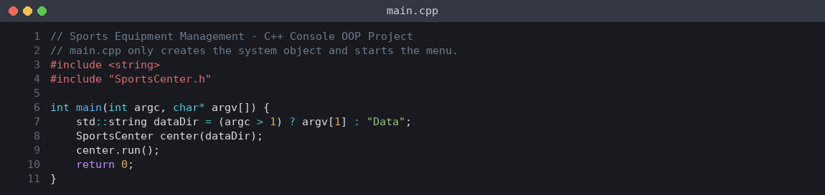
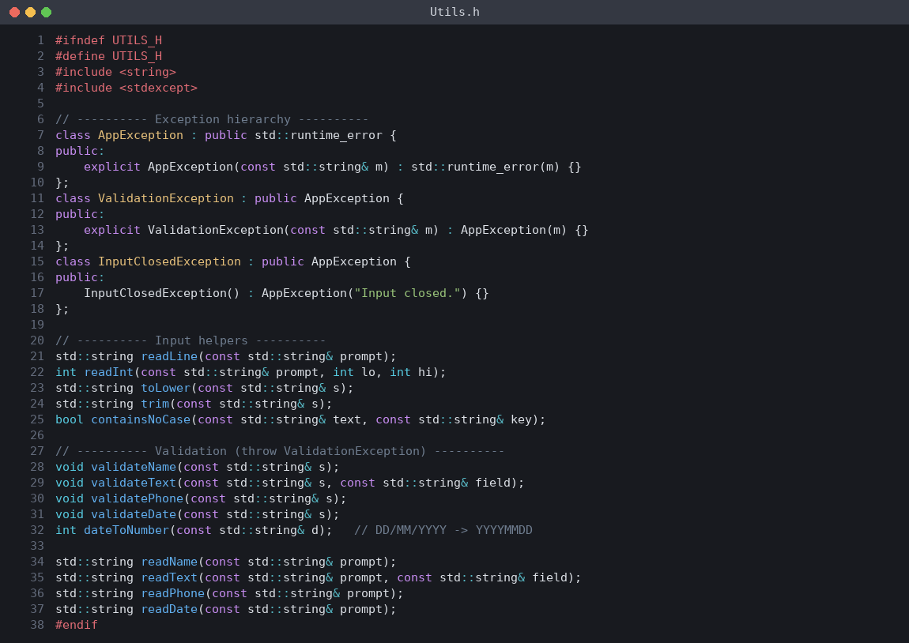
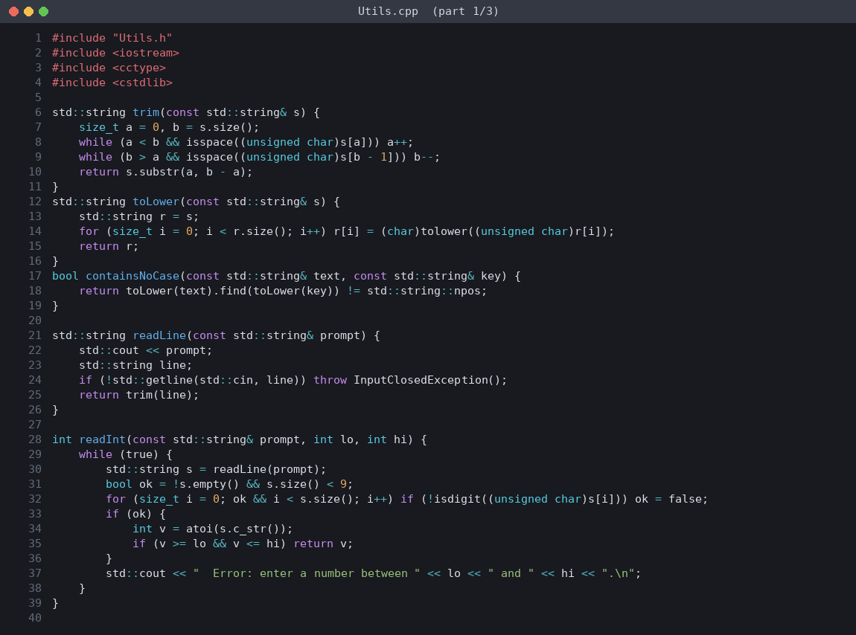
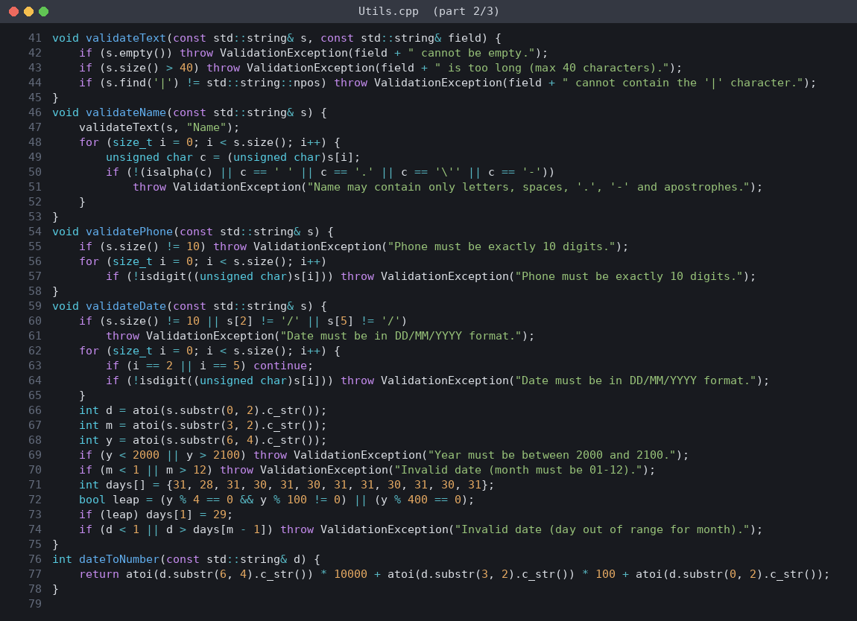
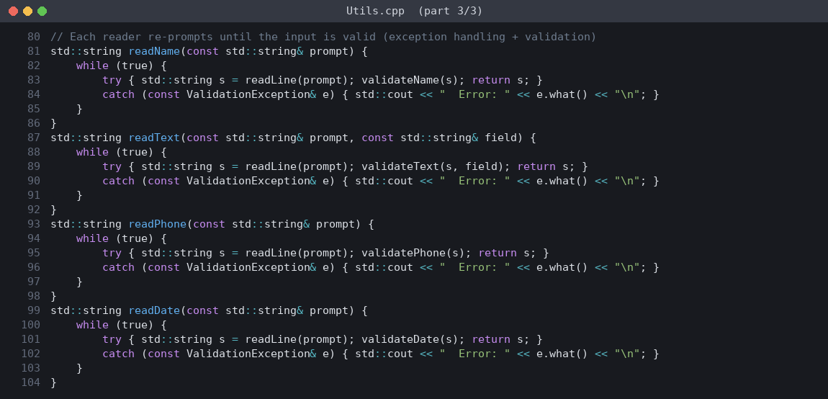
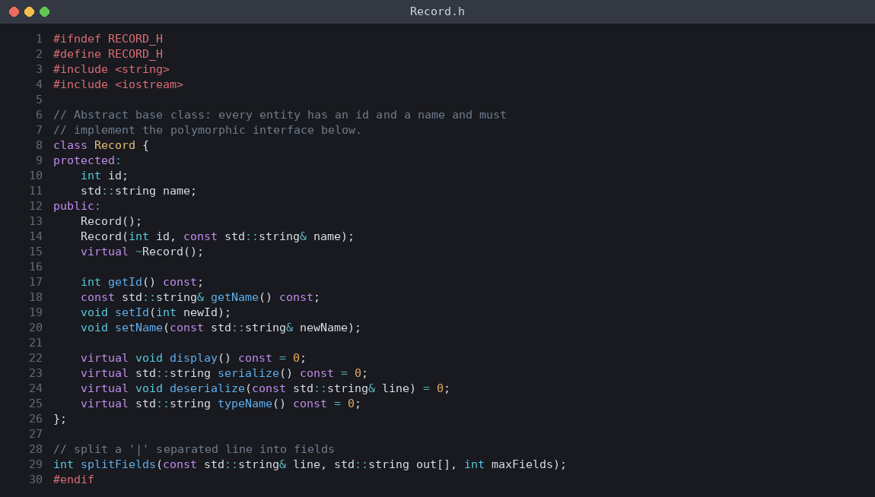
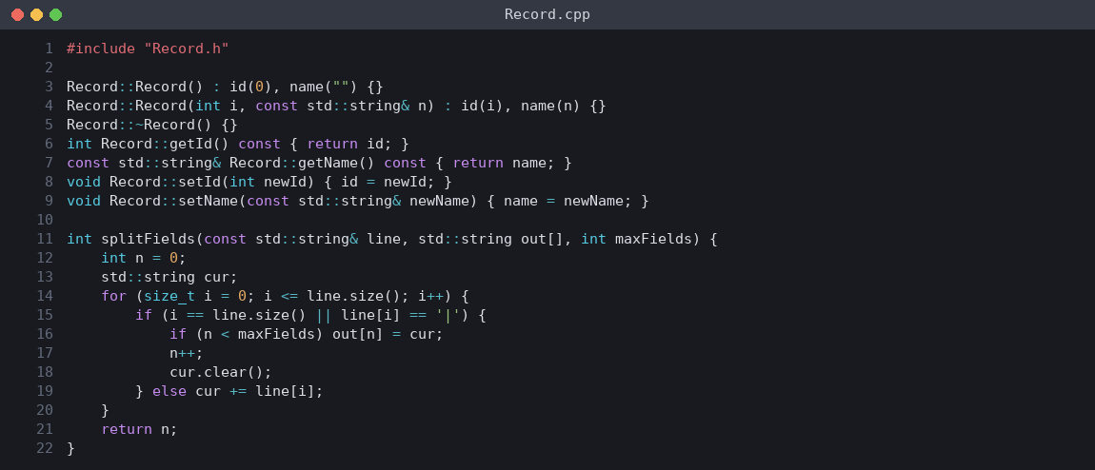
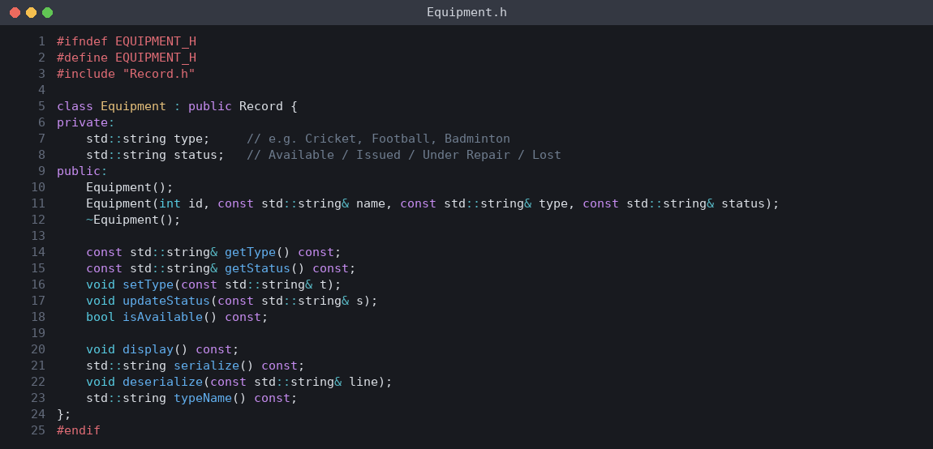
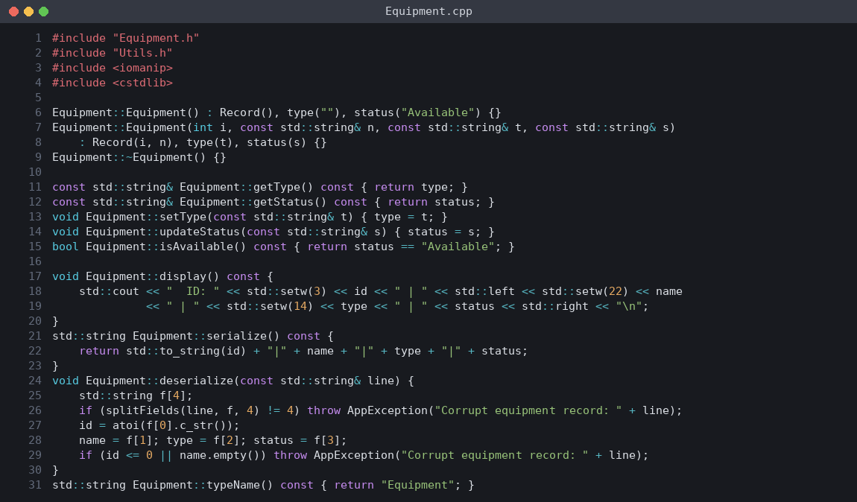
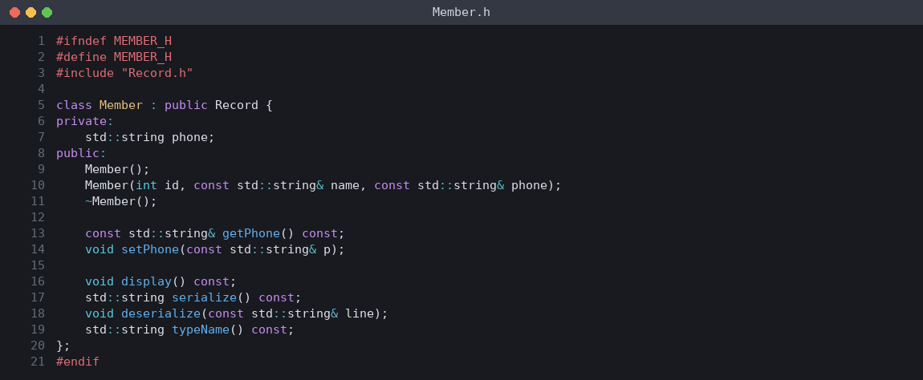
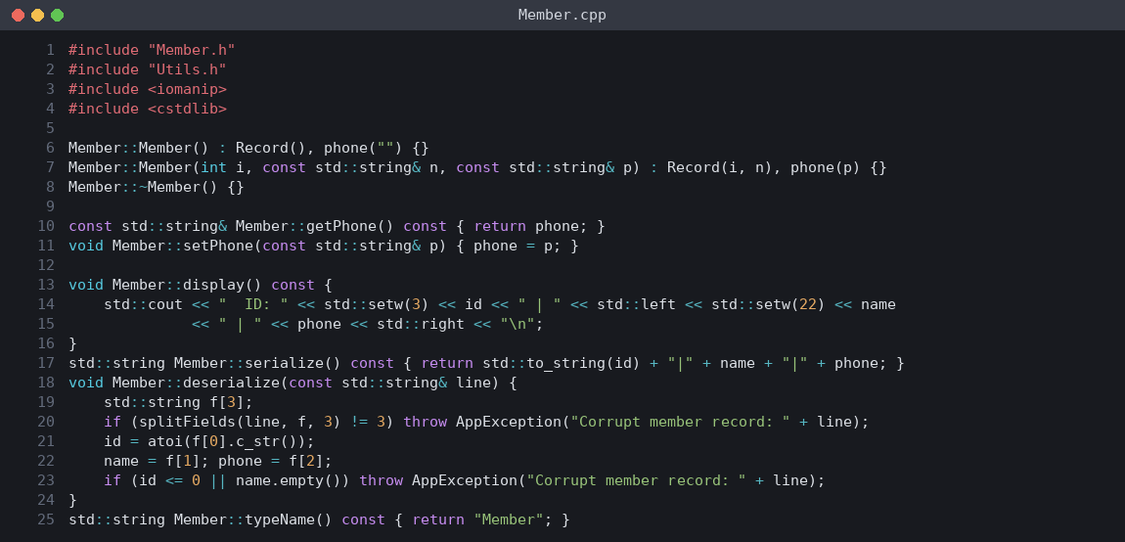
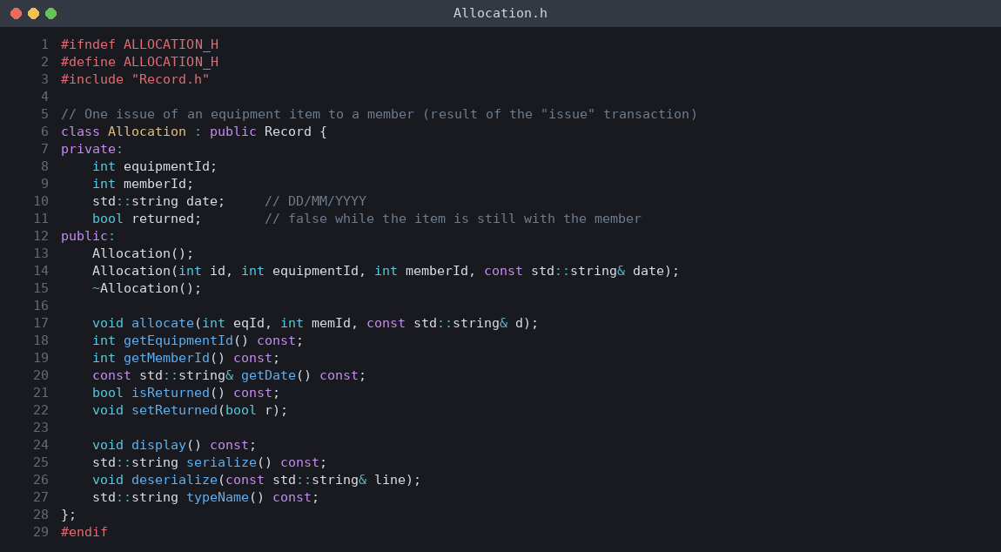
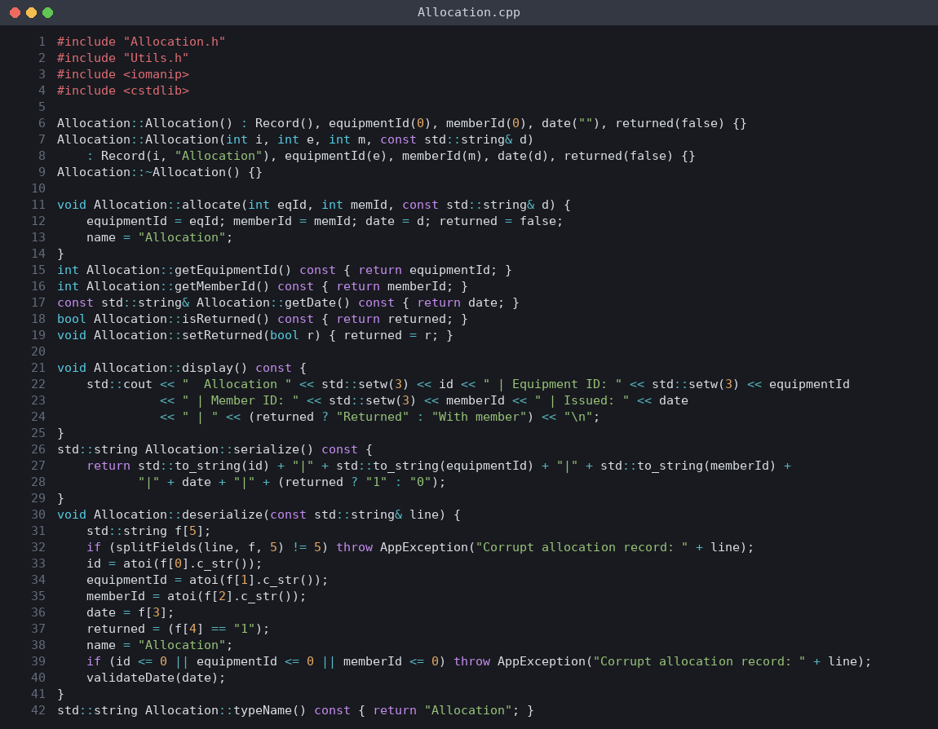
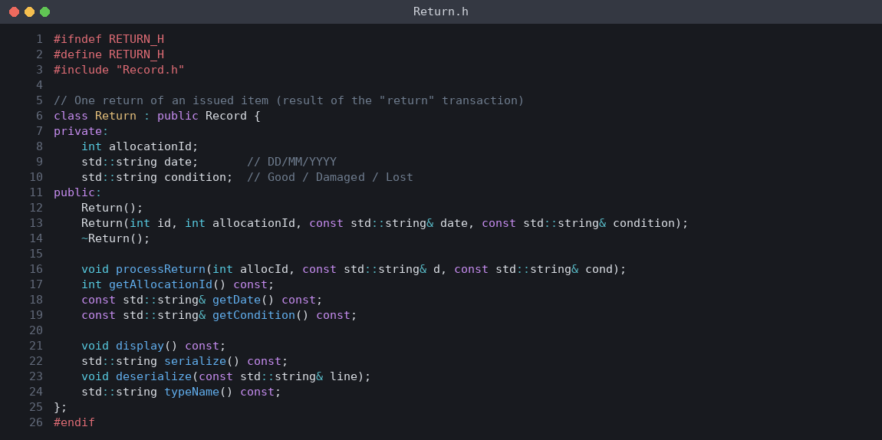
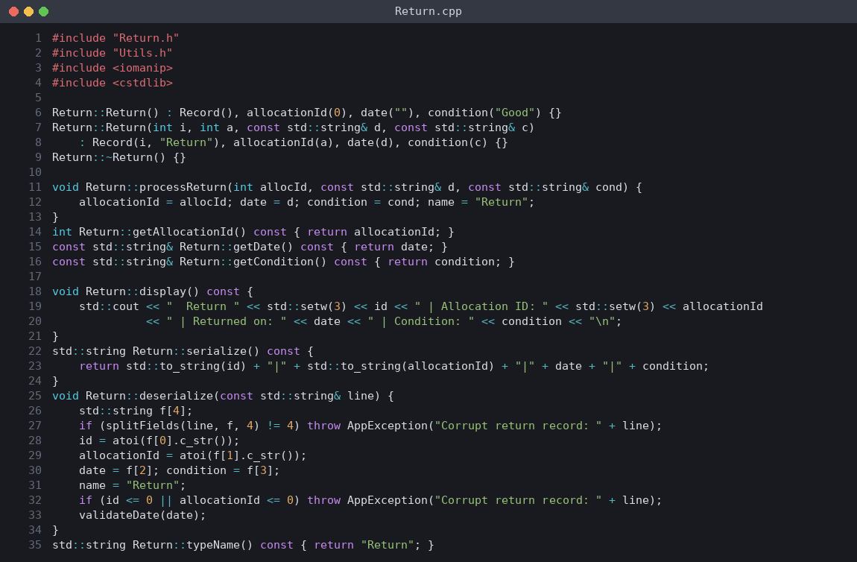
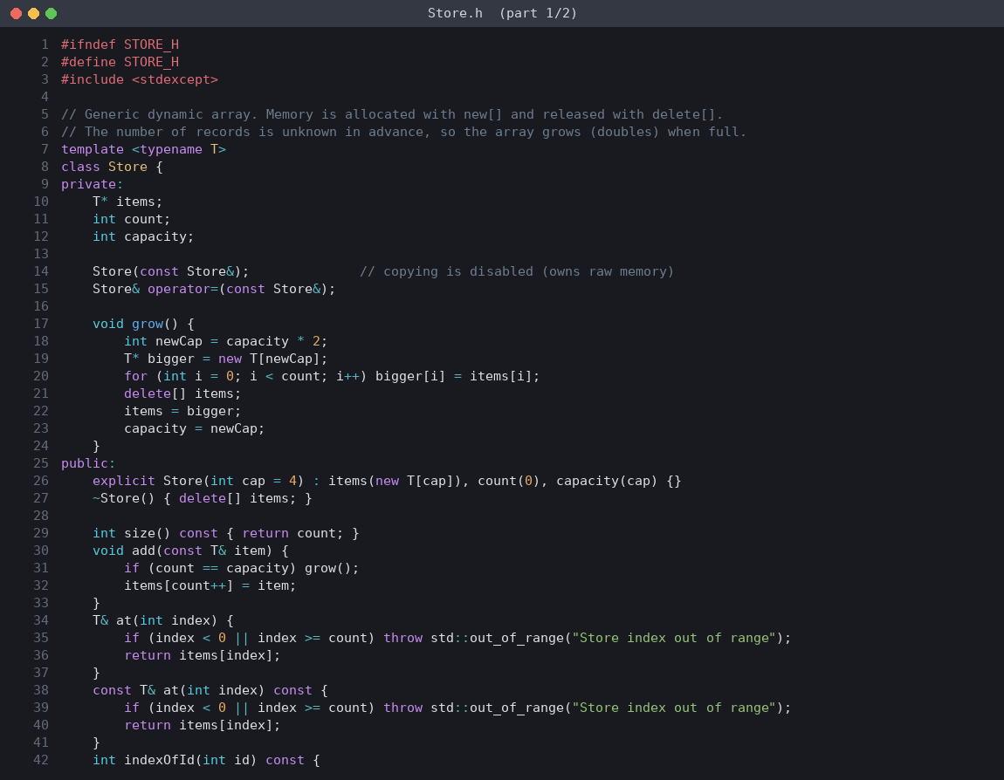
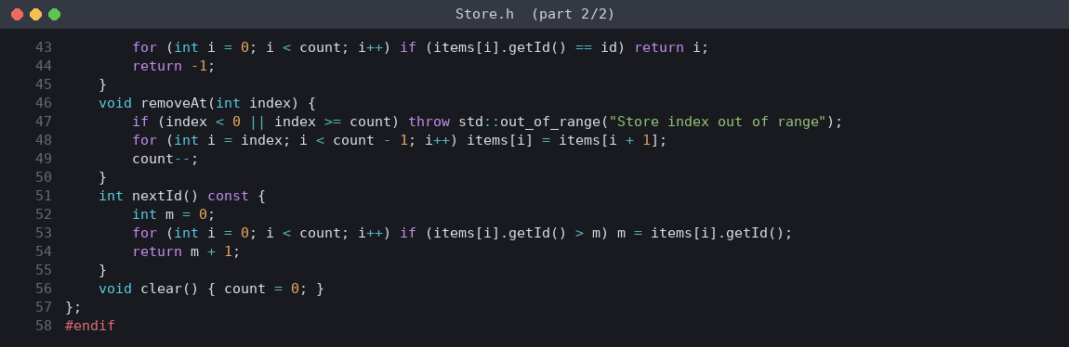
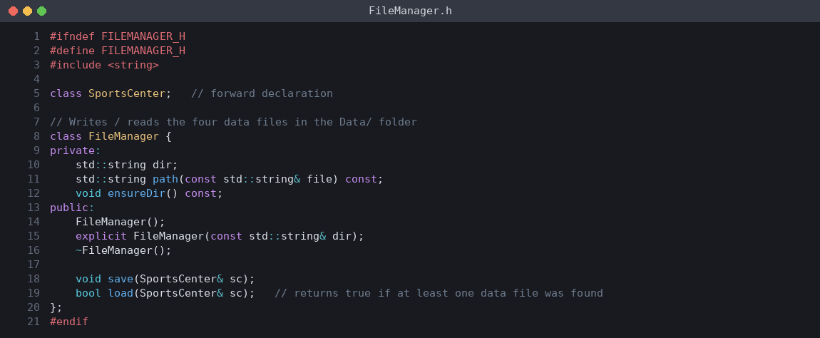
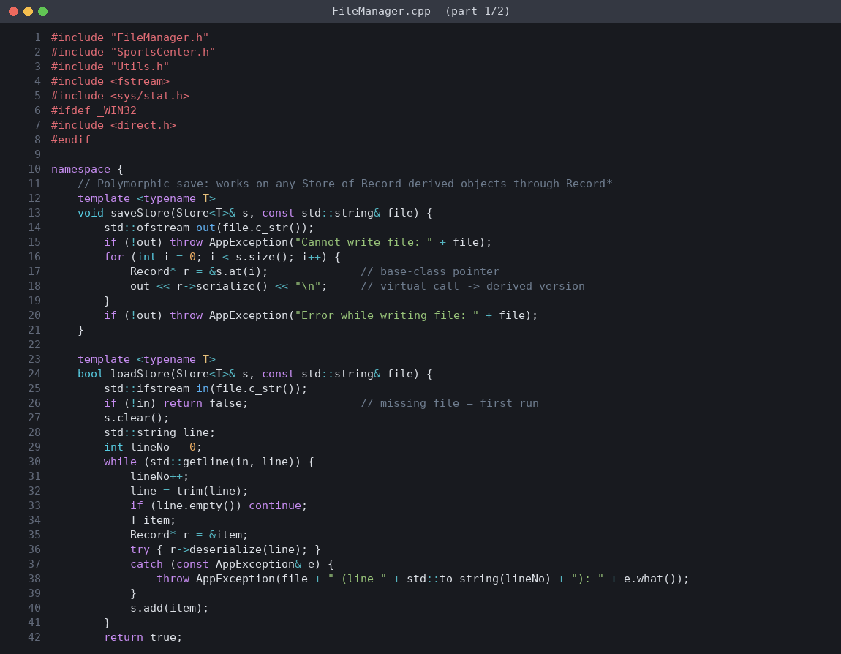
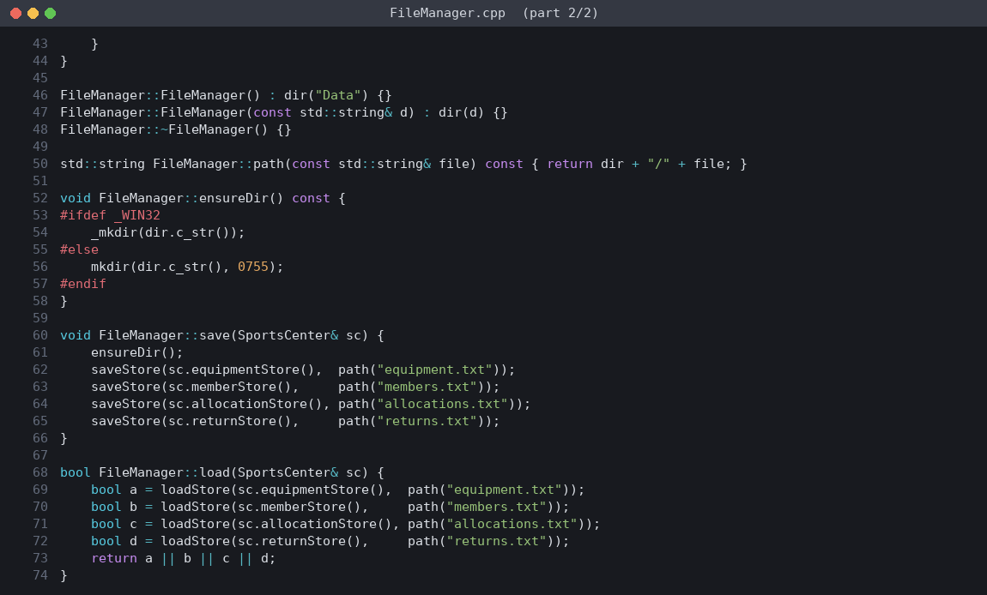
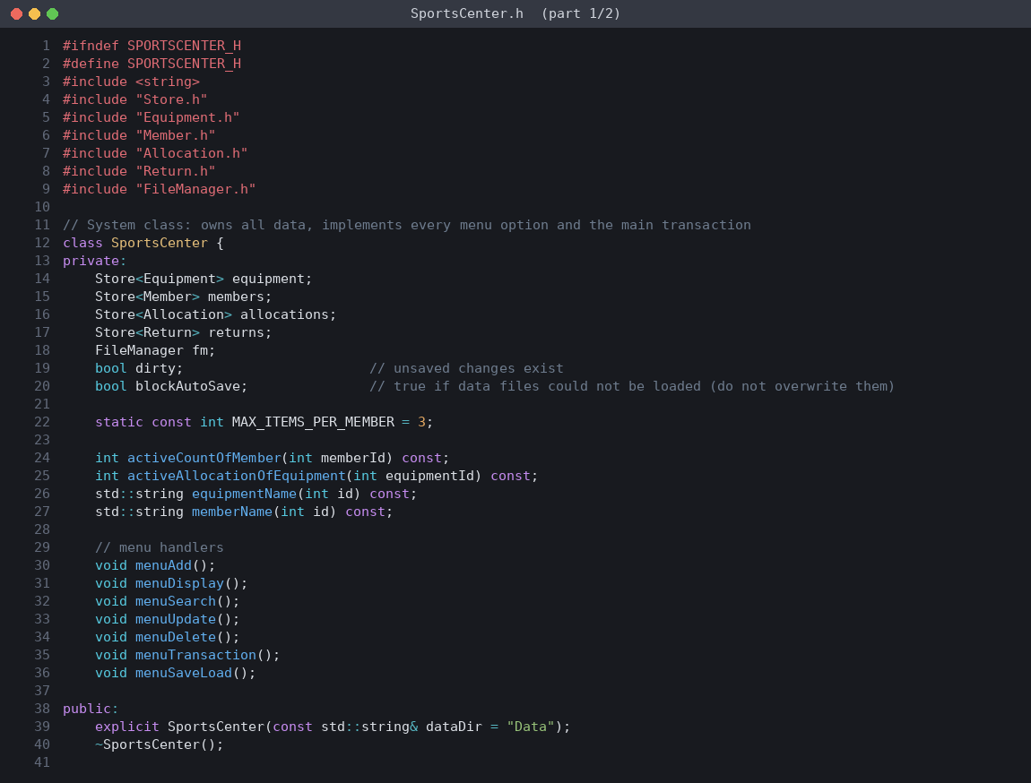
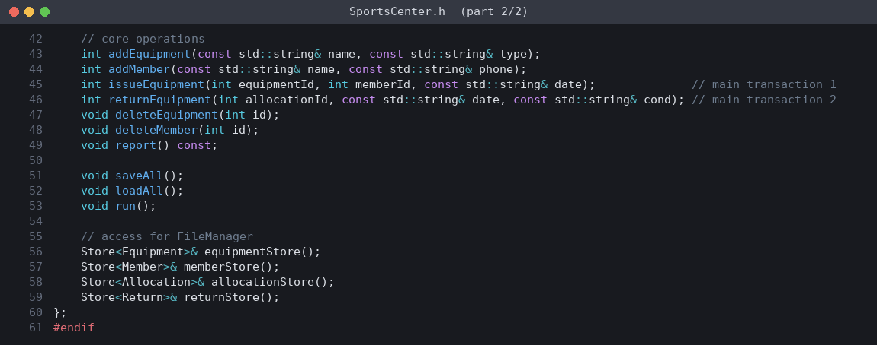
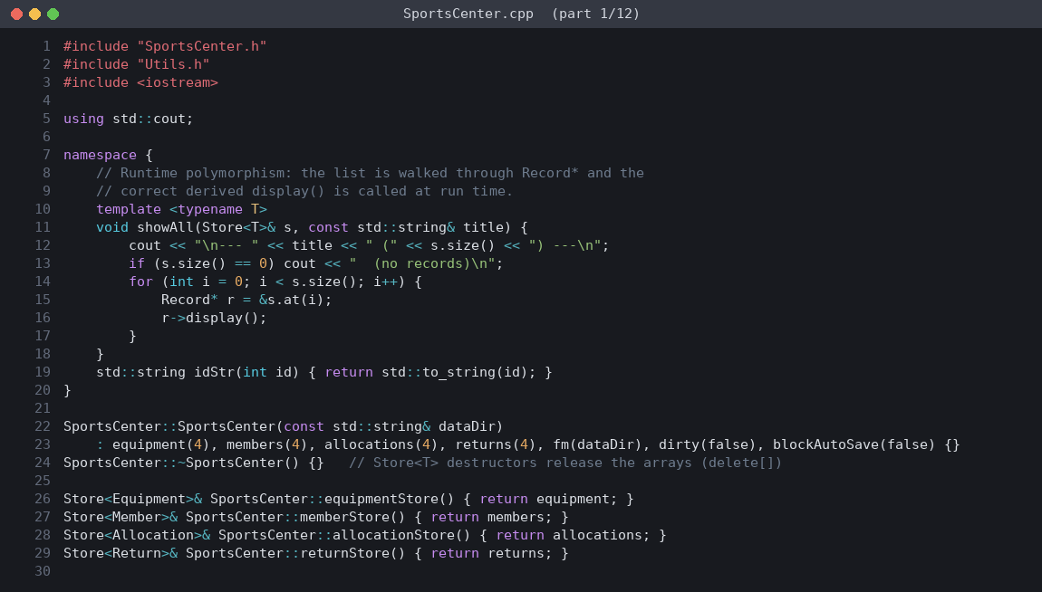
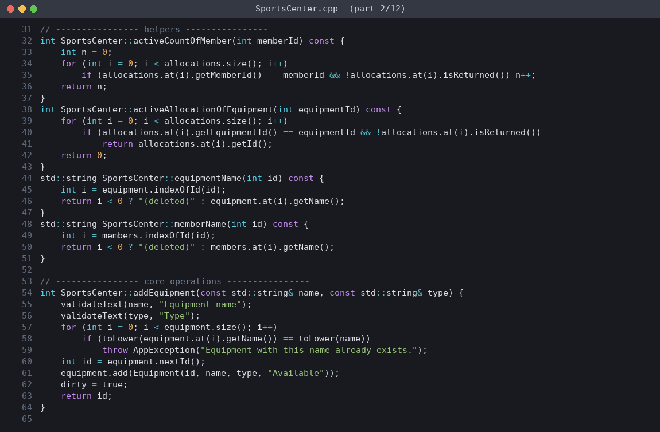
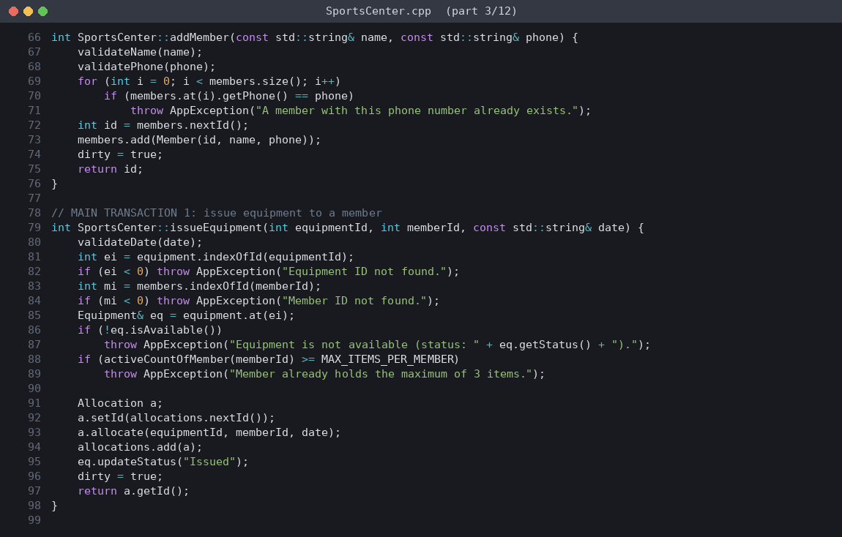
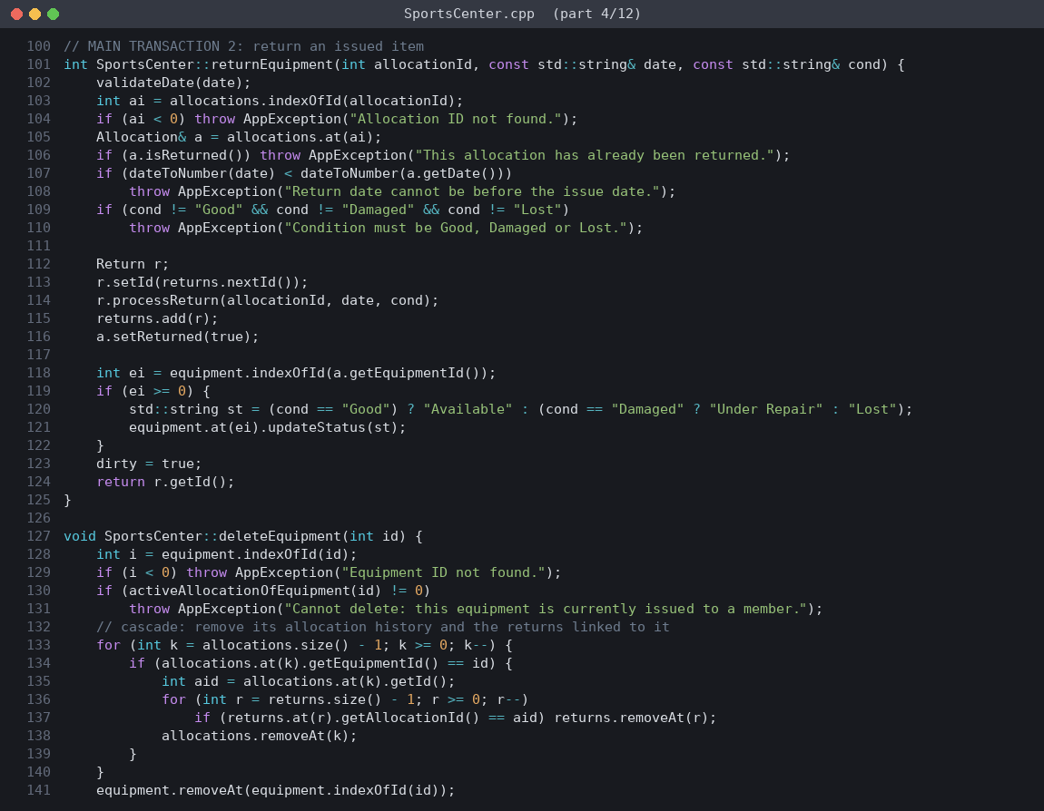
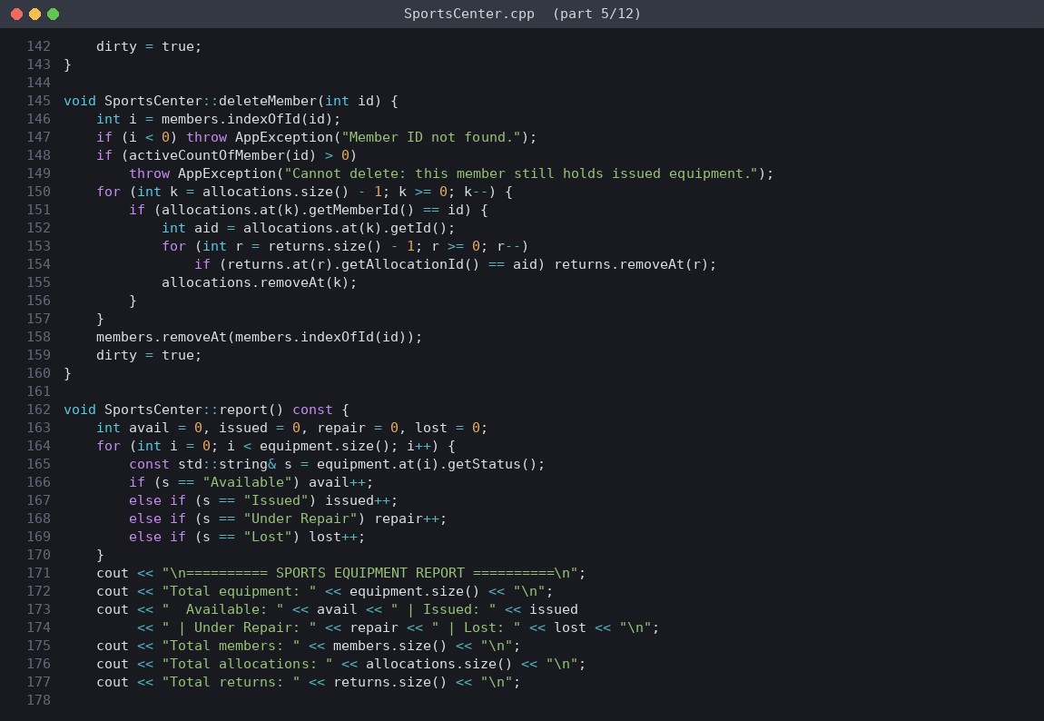
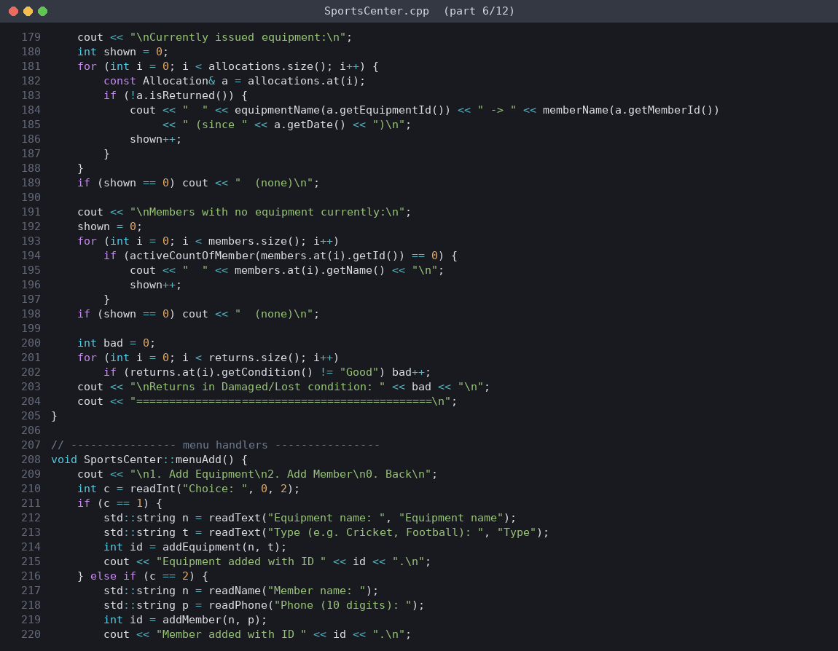
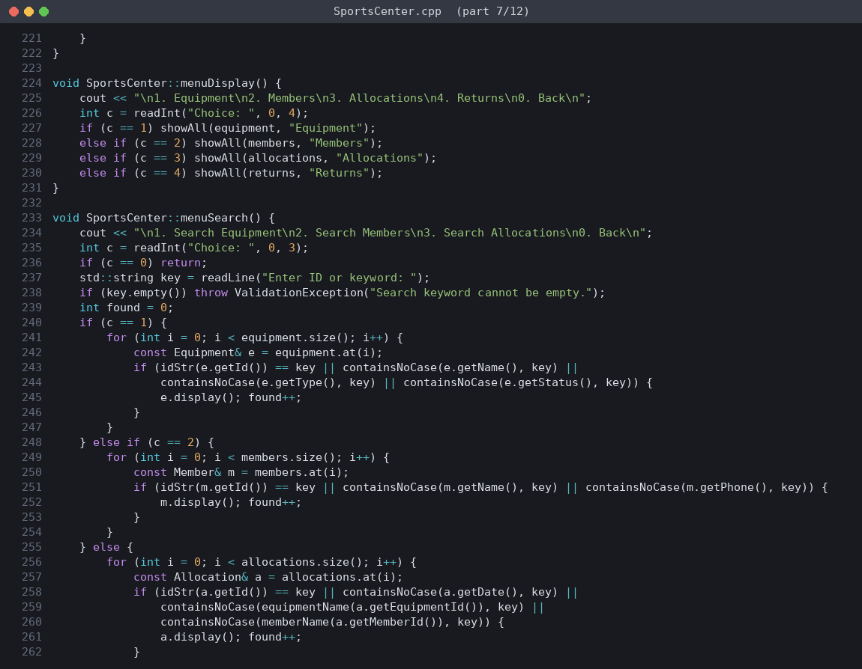
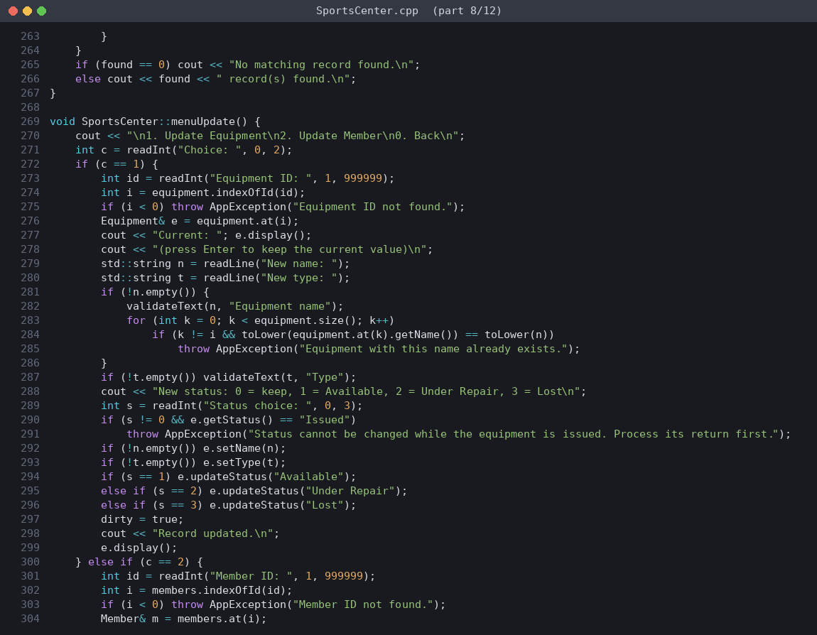
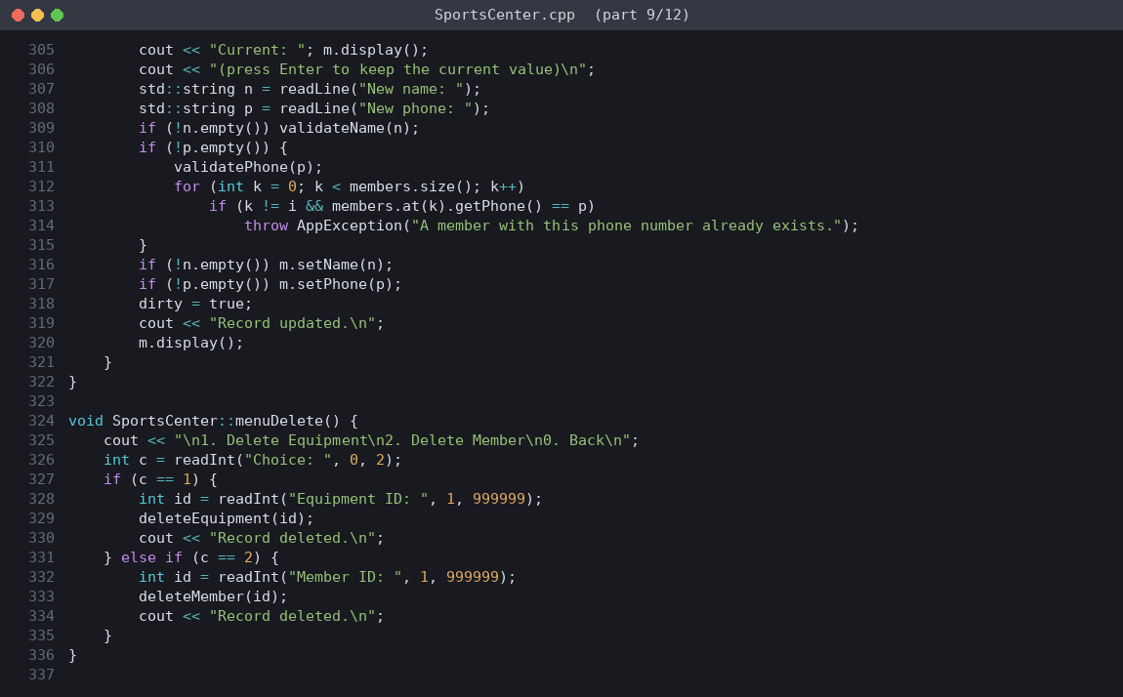
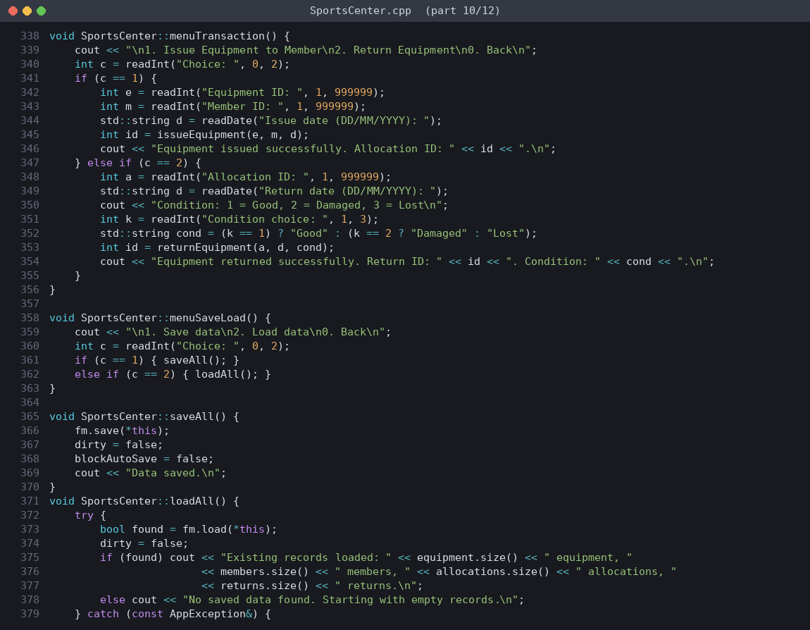
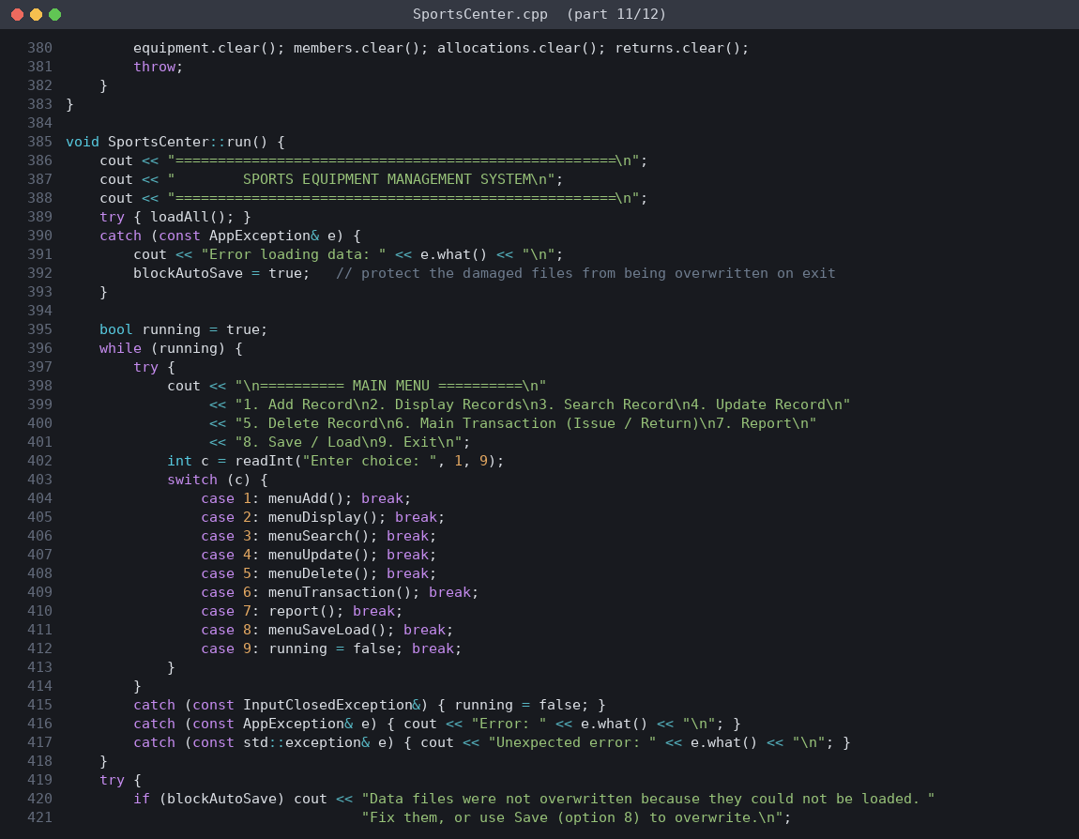
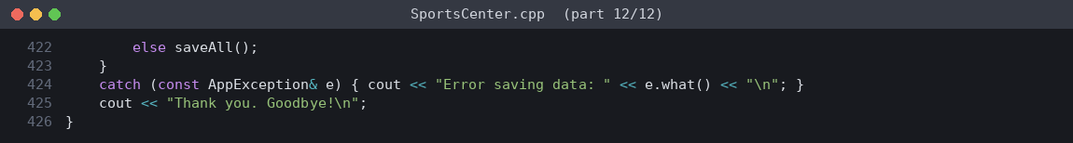
Program Output
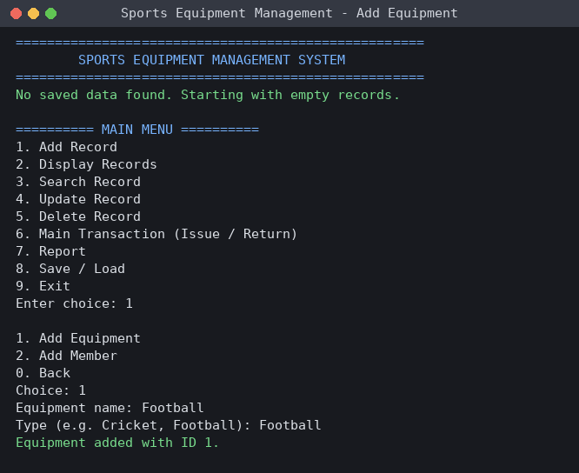
Screen 1: Adding equipment records (menu option 1 > 1)
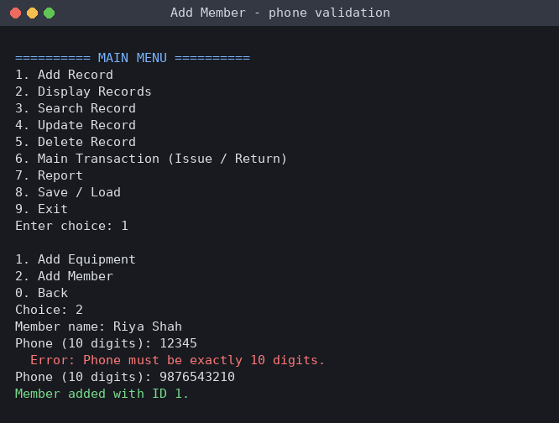
Screen 2: Adding a member (invalid phone number rejected, then accepted)
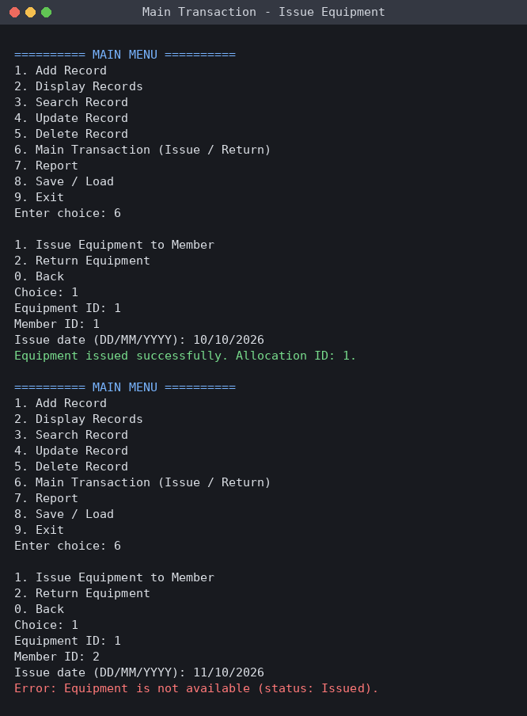
Screen 3: Main transaction - issuing equipment, and rejecting an item that is already issued
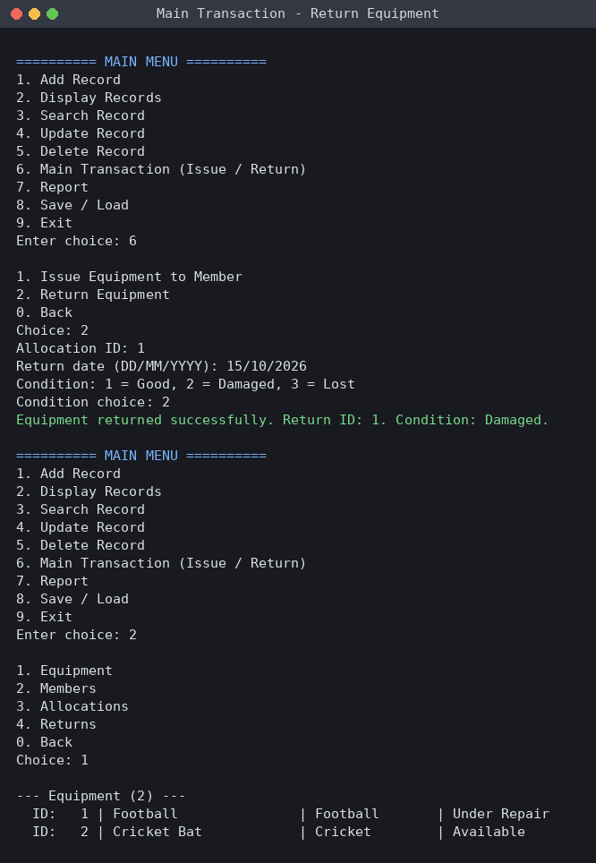
Screen 4: Main transaction - returning equipment as Damaged and viewing its new status
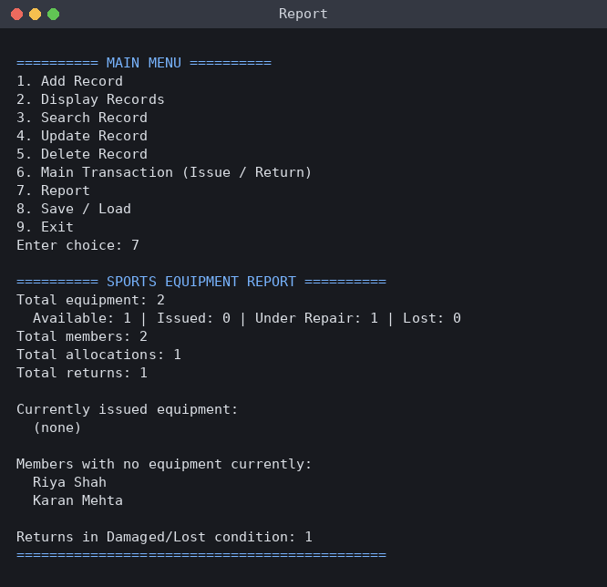
Screen 5: Report (menu option 7)
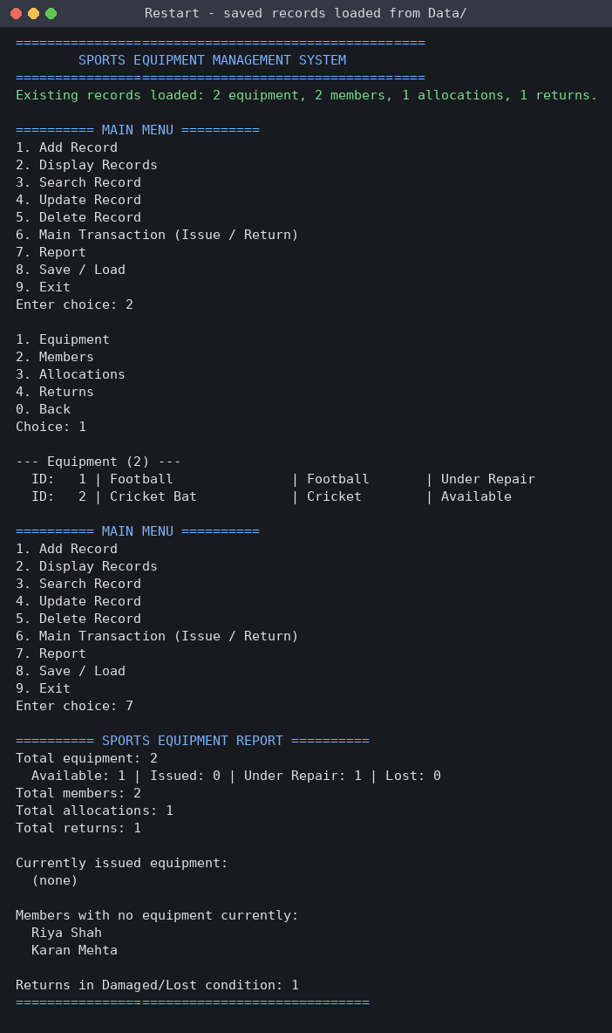
Screen 6: After restarting the program - saved records are loaded from the Data folder

13. Limitations
- The application is console-based and has no graphical interface.
- Data is stored in text files, not in a database, so it is suited to small and medium amounts of data.
- It is a single-user program without login or access control.
- The limit of 3 items per member is fixed in the code and there is no overdue or fine calculation.

14. Future Scope
- Add a graphical user interface or a web front end.
- Store data in a database such as SQLite or MySQL.
- Add user login with separate roles for staff and members.
- Add due dates, overdue alerts and automatic fines.
- Add barcode or QR-code scanning for faster issue and return.

15. Conclusion
The Sports Equipment Management system meets all the requirements of the blueprint. It uses classes, encapsulation, constructors and destructors, inheritance with runtime polymorphism, dynamic memory, file handling, validation and exception handling in a single working application. All 15 test cases pass, data survives program restarts, and invalid operations are rejected with clear messages. The project helped in understanding how OOP concepts work together in a complete program, and it can be extended easily in the future.

